PROGRAMMING IN JAVA
ASSIGNMENT 2 – CO2
CO2 Coverage: Strings and StringBuilder, regular expressions, the Collection Framework –List, Queue, Deque, PriorityQueue, Set and Map, the hashCode–equals contract, Generics, Comparable and Comparator, and the Collections utility class (Sessions 15–26).
Nature of Assignment: Individual
Duration: 1 Week
Total Marks: 50
Submission Date: _____8/11/2026_____________
Mandatory Execution and GitHub Submission
• Every student must individually execute every task in this assignment, includingall “Complete the Code” programs.
• Create a GitHub repository named CSA09-<RegisterNumber>-Assignment2 andshareit with the course faculty (public, or private with the faculty added as a collaborator). • Keep one folder for each task (for example: Task01, Task02 …or Q1, Q2 …), containingthe Java source code, input files and output screenshots.
• Include a README.md with your name, register number, Java version, the steps tocompile and run each program, and a short note of the result of each task. • Commit your work progressively – at least one commit for each task. The commit historywill be checked; a single upload of all files on the last day will not be accepted. • Submit the GitHub link below and on the cover page of your report. An assignment submitted without a working GitHub link will not be evaluated.
GitHub Repository Link: _____________https://github.com/192572027simats-del/CSA0922-JAVA-PROGRAMING/tree/main/ASSIGNMENT%202_____________________________________ How to Answer the Additional Questions
Complete the Code: Copy the given code into your repository, replace every TODOwithworking code without changing the rest of the program, execute it and compare your output withthe expected output.
Alternative Concept and Complexity Analysis: Describe how the solution would changeif thealternative concept were used, with code or pseudocode, and analyse and compare thetimecomplexity and space complexity of both solutions using Big-O notation, supported by your ownmeasurements wherever possible.
Q1 – Building Text Under Load: String, StringBuilder or StringBuffer? 6MarksBloom’s Level: K4 – Analyse
Problem Context – Railway e-Ticket Generation
A railway reservation system generates an e-ticket for every booking. Each e-ticket is built byjoining many fields – PNR, passenger names, coach, berth, fare and journey details –intoasingle printable text block. The current code builds the ticket using the + operator inside aloop.
Your Challenge
Investigate whether the choice of String, StringBuilder or StringBuffer matters for this task, or whether the difference is negligible.
CSA09 – Programming in Java – Assignments CO1–CO5 | Page 1
Before implementation:
• Predict how the three approaches will behave as the number of fields and tickets increases.
• Explain the reason for your prediction using String immutability and object creation.
Design two deliberately contrasting workloads (for example: one short ticket, 10,000 ticketswith50 fields each) and one additional workload of your own.
Implement the three approaches and record appropriate measures such as: • Execution time (System.nanoTime(), averaged over repeated runs) • Number of intermediate String objects created (estimated)
• Memory used before and after
Compare your prediction with the observed behaviour.
Design Decision
The ticket generator will now run inside a multithreaded booking server, and several threadsmayappend to a shared booking log. Determine which class you would recommend for the per-ticket text and which for the shared log, and defend your decision.
Alternative Concept and Complexity Analysis
If String.join(), StringJoiner or String.format() were used instead of StringBuilder to buildeachticket, what would the solution be? Derive the time complexity of building a ticket of n fields usingrepeated + (O(n²) characters copied) versus StringBuilder (O(n)), and analyse the extraspacecreated by intermediate String objects in each approach.
Evidence Expected
Reasoned prediction, three deliberately designed workloads, implementation of thethreeapproaches, measured evidence, comparison of predicted and observed behaviour, andanevidence-based recommendation.

Answer:

prediction in the report
Prediction:
- String concatenation using + inside a loop may be slower because String objects are immutable.
- StringBuilder is expected to be faster because it modifies the same mutable character sequence.
- StringBuffer may be slightly slower than StringBuilder because its methods are synchronized.
- For a small ticket, the difference may be negligible.
- For a large number of tickets with many fields, the difference may become noticeable..

Design three workloads
The assignment requires three deliberately contrasting workloads.
Use these:
Workload | Number of tickets | Fields per ticket
Workload 1 – Small | 1 | 10
Workload 2 – Medium | 1,000 | 20
Workload 3 – Large | 10,000 | 50
For each workload, generate ticket text using all three approaches.
This gives you nine experiments in total.
design decision
The assignment introduces a new condition: the ticket generator runs in a multithreaded booking server, and multiple threads may append to a shared booking log.
Situation | Your decision to investigate
Building an individual ticket | StringBuilder or another suitable approach
Shared log accessed by multiple threads | StringBuffer, or an appropriately synchronized design

Complete the alternative concept analysis
- String.join()
- StringJoiner
- String.format()
Approach | Expected time complexity
Repeated String concatenation | Can be $O(n^{2})$ in characters copied
StringBuilder | $O(n)$ in the total characters appended

Program:

public class Main {

static volatile long resultHolder;

// Workload settings
static int[] ticketCounts = {1, 1000, 10000};
static int[] fieldCounts = {10, 20, 50};

// Create ticket using String
static String createUsingString(int fields) {
String ticket = "";

for (int i = 1; i <= fields; i++) {
ticket = ticket + "Field" + i + ":Value" + i + "\n";
}

return ticket;
}

// Create ticket using StringBuilder
static String createUsingBuilder(int fields) {
StringBuilder ticket = new StringBuilder();

for (int i = 1; i <= fields; i++) {
ticket.append("Field")
.append(i)
.append(":Value")
.append(i)
.append("\n");
}

return ticket.toString();
}

// Create ticket using StringBuffer
static String createUsingBuffer(int fields) {
StringBuffer ticket = new StringBuffer();

for (int i = 1; i <= fields; i++) {
ticket.append("Field")
.append(i)
.append(":Value")
.append(i)
.append("\n");
}

return ticket.toString();
}

// Measure String approach
static long measureString(int tickets, int fields) {
long start = System.nanoTime();

for (int i = 0; i < tickets; i++) {
resultHolder += createUsingString(fields).length();
}

return System.nanoTime() - start;
}

// Measure StringBuilder approach
static long measureBuilder(int tickets, int fields) {
long start = System.nanoTime();

for (int i = 0; i < tickets; i++) {
resultHolder += createUsingBuilder(fields).length();
}

return System.nanoTime() - start;
}

// Measure StringBuffer approach
static long measureBuffer(int tickets, int fields) {
long start = System.nanoTime();

for (int i = 0; i < tickets; i++) {
resultHolder += createUsingBuffer(fields).length();
}

return System.nanoTime() - start;
}

// Average of repeated measurements
static double averageTime(int method, int tickets, int fields) {

long total = 0;
int repetitions = 5;

// Warm-up runs
for (int i = 0; i < 2; i++) {
if (method == 1)
measureString(tickets, fields);
else if (method == 2)
measureBuilder(tickets, fields);
else
measureBuffer(tickets, fields);
}

for (int i = 0; i < repetitions; i++) {

long time;

if (method == 1)
time = measureString(tickets, fields);
else if (method == 2)
time = measureBuilder(tickets, fields);
else
time = measureBuffer(tickets, fields);

total += time;
}

return total / (double) repetitions;
}

public static void main(String[] args) {

System.out.println("STRING PERFORMANCE COMPARISON");
System.out.println("--------------------------------------------");

System.out.printf(
"%-12s %-15s %-18s %-18s%n",
"Workload", "String(ns)",
"StringBuilder(ns)", "StringBuffer(ns)"
);

for (int i = 0; i < ticketCounts.length; i++) {

int tickets = ticketCounts[i];
int fields = fieldCounts[i];

double stringTime =
averageTime(1, tickets, fields);

double builderTime =
averageTime(2, tickets, fields);

double bufferTime =
averageTime(3, tickets, fields);

System.out.printf(
"%-12s %-15.0f %-18.0f %-18.0f%n",
tickets + " tickets",
stringTime,
builderTime,
bufferTime
);
}

System.out.println("--------------------------------------------");
System.out.println("Total result value: " + resultHolder);
}
}

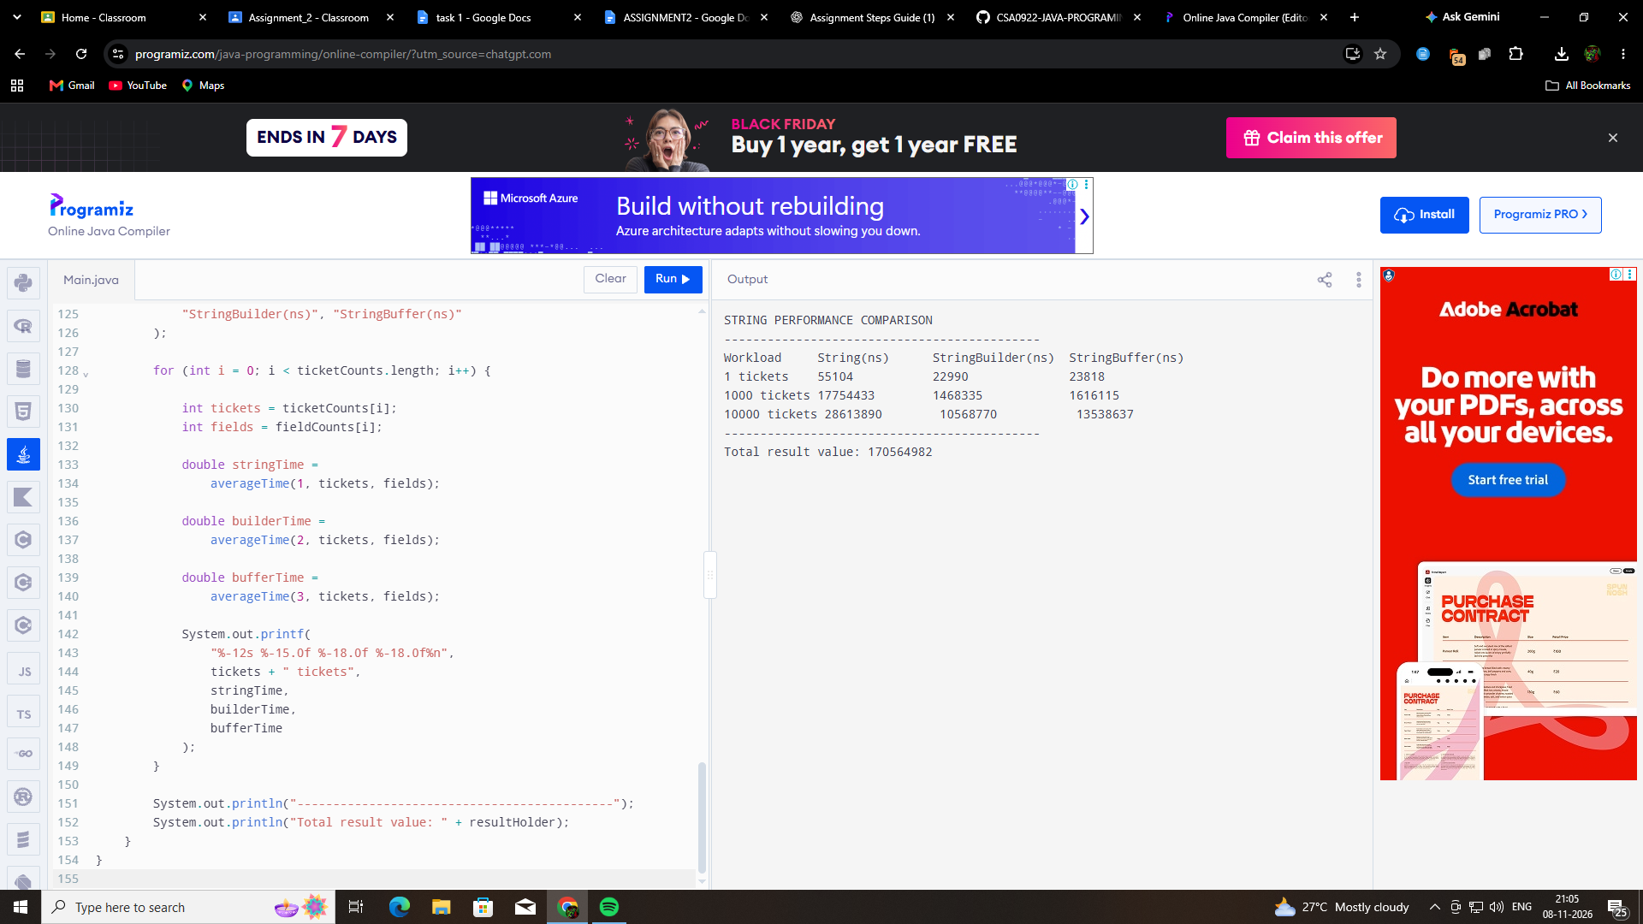

Workload | String (ns) | StringBuilder (ns) | StringBuffer (ns)
1 ticket | 55,104 | 22,990 | 23,818
1,000 tickets | 17,754,433 | 1,468,335 | 1,616,115
10,000 tickets | 286,139,890 | 105,687,770 | 135,386,637
These are your measured results. Save this screenshot as evidence in your Task01 folder.

results
Observation 1 – String
String took the longest time in all three workloads. Repeated concatenation can create many intermediate String objects because String objects are immutable.
Observation 2 – StringBuilder
StringBuilder was the fastest in all three of your measurements. It builds text using a mutable character sequence, avoiding much of the repeated copying.
Observation 3 – StringBuffer
StringBuffer was slightly slower than StringBuilder in all three measurements. Its methods are synchronized, which adds overhead.
observation

Experimental Results and Observations
The experiment compared String, StringBuilder and StringBuffer using three workloads: 1 ticket with 10 fields, 1,000 tickets with 20 fields, and 10,000 tickets with 50 fields.
The measured results showed that StringBuilder performed the fastest in all three workloads. StringBuffer was the second fastest, while String concatenation using String was the slowest.
The results support the prediction that StringBuilder is more efficient for repeated text construction because it modifies a mutable character sequence instead of repeatedly creating new String objects.
StringBuffer showed slightly higher execution times than StringBuilder, which is consistent with the additional synchronization overhead of its methods.
Therefore, StringBuilder is a suitable choice for generating individual railway tickets, while StringBuffer can be considered when multiple threads need to append to the same shared text buffer.

